About the SOAP Nodes sample
The SOAP Nodes sample shows how the SOAPInput, SOAPReply, and SOAPRequest nodes can be used to both provide and consume a Web service through an HTTP or JMS transport.
The starting point for the sample is a Web Services Description Language (WSDL) file that defines a simplified ordering service, see WSDL file. The WSDL file, which contains both HTTP and JMS bindings, points to the operations that are defined in the WSDL. The Web service always returns a response indicating the part ordered is available; an option for extending the Web service might be to use a Database node to query a stock database.
The "Start from WSDL and/or XSD files" wizard is used with the WSDL file to create the message set, and two message flows that compose this sample.
The SOAP Nodes sample demonstrates the following tasks:
- How to provide a Web service by using SOAPInput and SOAPReply nodes through HTTP or JMS transport.
- How to consume a Web service by using a SOAPRequest node through HTTP or JMS transport.
- How to query the WSDL used to configure a Web service provider flow.

Running the SOAP Nodes sample
Running the SOAP Nodes sample consists of putting a message through the consumer message flow. To run this sample you can use the Test Client to put input messages to the message flow.
Before you run the sample, verify that your Web services consumer is configured correctly for HTTP flows and that JNDI administered objects are configured for JMS flows, see Setting up the JMS part of SOAP Nodes sample.
If you encounter any problems when you run the sample, see Resolving problems when running samples in the WebSphere Message Broker documentation.

Verifying that the consumer has the correct properties for the provider
- SOAP over HTTP:
If you want to verify that your Web services consumer is configured correctly, complete all of the following steps. If you have set up a TCP/IP Monitor, you have already checked which port the Web services provider is using, but you must still configure the consumer to send the messages to your TCP/IP Monitor and then build and redeploy the broker archive (BAR) file.
The default port that Web services use is 7800, and the SOAPRequest node is set up to use this port. However, if this port is already in use, the port number is incremented by one.
To check which port your provider execution group is using, issue the following mqsireportproperties command:
mqsireportproperties MB7BROKER -e sampleExecutionGroup -o HTTPConnector -n port
Where sampleExecutionGroup is the execution group for your sample.
To verify that the port that the SOAPRequest node is using is the correct port to call the provider flow, change the port of the SOAPRequest node to the port that the provider execution group is using by completing the following steps:
  - Open the message flow located in the message flow project.
  - Open the HTTP Transport tab in the Properties view. If the port is already correct, you have finished setting up the sample. If the port is not correct, change the port in the Web service URL property to the correct port for your Web services provider or for your TCP/IP Monitor.
  - Save the message flow. You must now rebuild and redeploy the BAR file.

The message flows
The sample uses two message flows. One message flow provides a Web service and the other consumes a Web service. The request and response message remain the same in the case of HTTP and JMS Web Services. The message flows are described later in this section.
The following diagram shows the Web Service Provider message flow:
SOAPNodesSampleConsumerFlow.msgflow
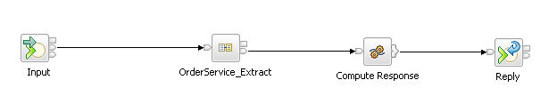
The following table shows the nodes in the Web Service Provider message flow:
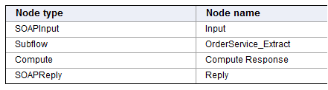

The SOAPInput node receives incoming SOAP messages and, if they are valid, passes them down the message flow to the OrderService_Extract subflow. The OrderService_Extract subflow is created by the "Start from WSDL and/or XSD files" wizard. The following diagram shows the Web Service Provider subflow:
OrderService_SOAPNodesSampleProviderFlow.msgflow
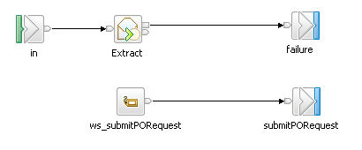
The following table shows the nodes in the Web Service Provider subflow:
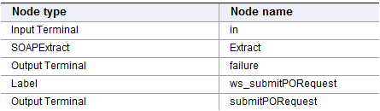

The SOAPExtract node takes a SOAP message and removes the SOAP envelope. In this sample, removing the SOAP envelope leaves an XML message in the XMLNSC domain that can be used in nodes such as the Mapping node or the Compute node. The SOAPExtract node then routes the message to a label based on the Web service operation that is being called. In this sample, only one operation is used. If the WSDL that is used as a starting point has multiple operations, the "Start from WSDL and/or XSD files" wizard gives the option of implementing more than one operation. If multiple operations are selected, the subflow has multiple labels, which produce multiple output terminals in the parent message flow.
When the XMLNSC message leaves the subflow and returns to the main provider message flow, it enters a Compute node. By using the Compute node, you can reference the original SOAP body as XML, and perform ESQL operations on the data in the message. In the sample, the data in the message is ignored, and valid XML data is created from scratch. This data is then sent to the SOAPReply node, which constructs a SOAP message to return to the Web service consumer that initiated the Web service call.
The following diagram shows the Web Service Consumer message flow:

SOAPNodesSampleConsumerFlow.msgflow
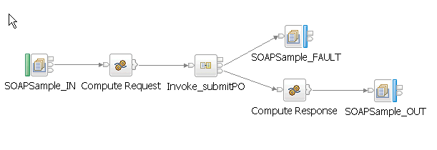
The following table shows the nodes in the Web Service Consumer message flow
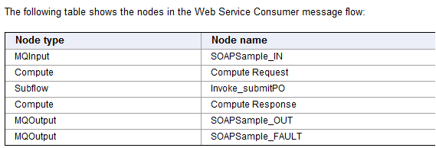

The Web Service Consumer flow is initiated by a WebSphere MQ message arriving on the queue monitored by the MQInput node. The message is an XML message in the XMLNSC domain. The message enters a Compute node where the incoming data is used to create the XML data to send to the Web service. The message is then passed down the flow to the Invoke_submitPO subflow. The Invoke_submitPO subflow is created by the "Start from WSDL and/or XSD files" wizard.
The following diagram shows the Web Service Consumer subflow:

submitPO_OrderService_SOAPNodesSampleConsumerFlow.msgflow
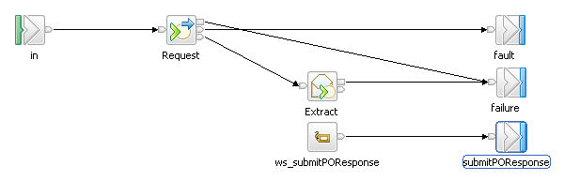
The following table shows the nodes in the Web Service Consumer subflow
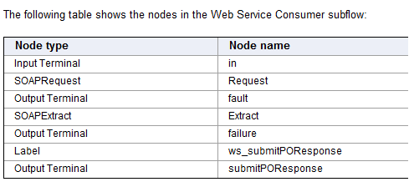

The SOAPRequest node takes the incoming XML data and uses it to build a valid SOAP message to send to the Web service that is defined by the node properties. If a valid response is received, it is passed to a SOAPExtract node, which removes the SOAP envelope from the response, and returns the message to the XMLNSC domain. The message is then routed to the ws_submitPOResponse Label node and exits the subflow.
In the main consumer flow, the output message is sent to an MQOutput node that writes the XML data to the specified WebSphere MQ queue. The fault message is sent to an MQOutput node that writes the SOAP Fault data to the specified WebSphere MQ queue.

The messages
The Web client message flow is driven by a WebSphere MQ message. A test client file is supplied for running the sample by using the following XML message:
<OrderMessage>
<localElement>
<FirstName>Message</FirstName>
<LastName>Broker</LastName>
<Street>IBM</Street>
<City>IBM</City>
<ZipCode>IBM</ZipCode>
<PartNumber>Some Part</PartNumber>
<Quantity>1</Quantity>
</localElement>
</OrderMessage>
The valid format for a Web service request message and response message is shown in the following edited schema extract:
<xsd:element name="submitPORequest">
...
<xsd:complexType>
<xsd:sequence>
<xsd:element name="partNo" type="xsd:string"/>
<xsd:element name="partQuantity" type="xsd:int"/>
<xsd:element name="personName">
<xsd:complexType>
<xsd:sequence>
<xsd:element name="firstName" type="xsd:string"/>
<xsd:element name="lastName" type="xsd:string"/>
</xsd:sequence>
</xsd:complexType>
</xsd:element>
<xsd:element name="address">
<xsd:complexType>
<xsd:sequence>
<xsd:element name="street" type="xsd:string"/>
<xsd:element name="city" type="xsd:string"/>
<xsd:element name="zipCode" type="xsd:string"/>
</xsd:sequence>
</xsd:complexType>
</xsd:element>
</xsd:sequence>
</xsd:complexType>
</xsd:element>
<xsd:element name="submitPOResponse">
...
<xsd:complexType>
<xsd:sequence>
<xsd:element name="orderStatus" type="xsd:string"/>
<xsd:element name="orderAmt" type="xsd:int"/>
<xsd:element name="partNo" type="xsd:string"/>
<xsd:element name="partQuantity" type="xsd:int"/>
</xsd:sequence>
</xsd:complexType>
</xsd:element>

Sample program for use with IBM WebSphere Message Broker
© Copyright International Business Machines Corporation 2007, 2010
Licensed Materials - Property of IBM
*/
CREATE COMPUTE MODULE SOAPNodesSampleConsumerFlow_Compute_Request
CREATE FUNCTION Main() RETURNS BOOLEAN
BEGIN
SET OutputRoot.XMLNSC.ns:submitPORequest.partNo = InputRoot.XMLNSC.OrderMessage.localElement.PartNumber;
SET OutputRoot.XMLNSC.ns:submitPORequest.partQuantity = InputRoot.XMLNSC.OrderMessage.localElement.Quantity;
SET OutputRoot.XMLNSC.ns:submitPORequest.personName.firstName = InputRoot.XMLNSC.OrderMessage.localElement.FirstName;
SET OutputRoot.XMLNSC.ns:submitPORequest.personName.lastName = InputRoot.XMLNSC.OrderMessage.localElement.LastName;
SET OutputRoot.XMLNSC.ns:submitPORequest.address.street = InputRoot.XMLNSC.OrderMessage.localElement.Street;
SET OutputRoot.XMLNSC.ns:submitPORequest.address.city = InputRoot.XMLNSC.OrderMessage.localElement.City;
SET OutputRoot.XMLNSC.ns:submitPORequest.address.zipCode = InputRoot.XMLNSC.OrderMessage.localElement.ZipCode;

RETURN TRUE;
END;
END MODULE;

CREATE COMPUTE MODULE SOAPNodesSampleConsumerFlow_Compute_Response
CREATE FUNCTION Main() RETURNS BOOLEAN
BEGIN
SET OutputRoot.Properties = InputRoot.Properties;
SET OutputRoot.XMLNSC = InputRoot.XMLNSC;
RETURN TRUE;
END;
END MODULE;

/*
Sample program for use with IBM WebSphere Message Broker
© Copyright International Business Machines Corporation 2007, 2010
Licensed Materials - Property of IBM
*/
DECLARE ns NAMESPACE 'http://www.acmeOrders.com/OrderService';

CREATE COMPUTE MODULE SOAPNodesSampleProviderFlow_Compute_Response
CREATE FUNCTION Main() RETURNS BOOLEAN
BEGIN

SET OutputRoot.XMLNSC.ns:submitPOResponse.orderStatus = 'AVAILABLE';
SET OutputRoot.XMLNSC.ns:submitPOResponse.orderAmt = 50;
SET OutputRoot.XMLNSC.ns:submitPOResponse.partNo = InputRoot.XMLNSC.ns:submitPORequest.partNo;
SET OutputRoot.XMLNSC.ns:submitPOResponse.partQuantity = InputRoot.XMLNSC.ns:submitPORequest.partQuantity;

RETURN TRUE;

END;

